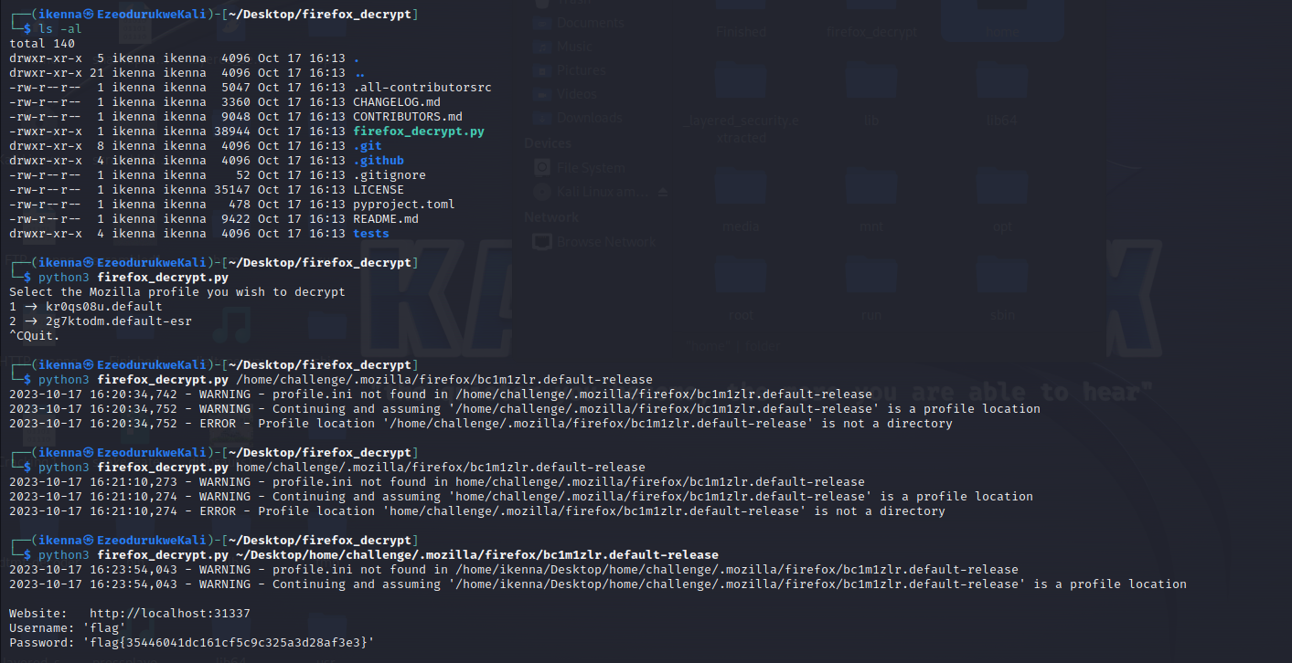
Firefox decrypt, foxes, etc

A payload in API is the actual data pack that is sent with the GET method in HTTP
https://www.nirsoft.net/utils/win_prefetch_view.html FORENSICS
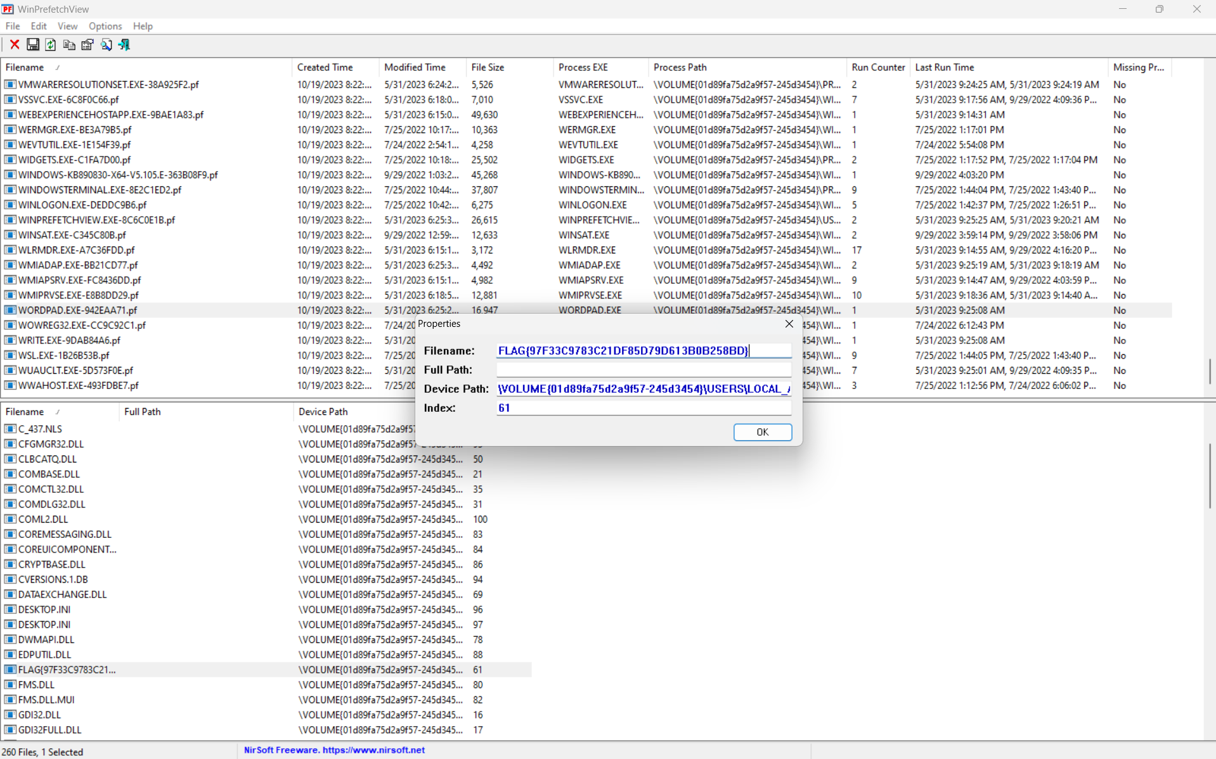
Options, advanced option, find specific folder where extracted file is.
flag{97f33c9783c21df85d79d613b0b258bd}

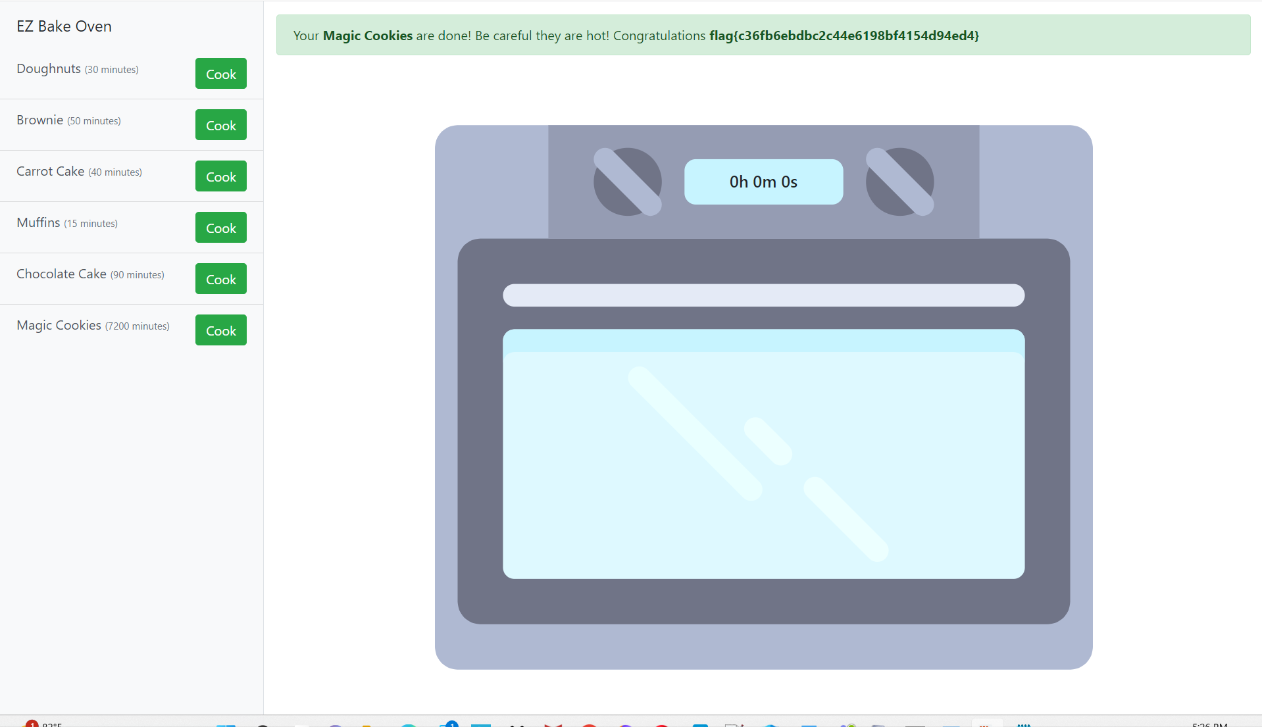
Encoded cookie to an earlier date after decoding the current cookie (base 64)

